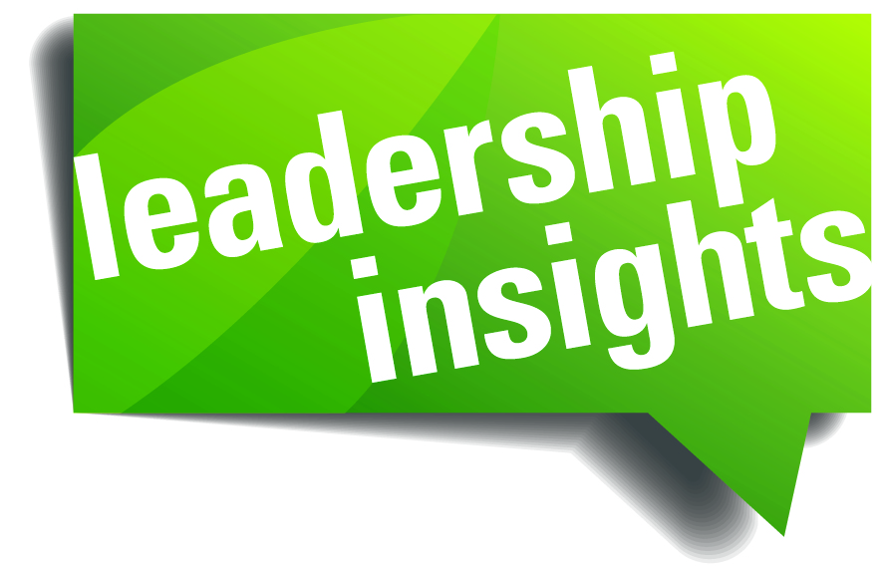
Q4 2016
Larry Prince, Ed.M.
CEO & Managing Member
Prince Health, LLC

Leadership and Coaching are Situational
There are numerous books and articles written about the best approach and style for leading and coaching our people. Examples are: Collaborative, Direct, Authoritative, Transactional and Transformational models - the list goes on. So, what's the answer? What is the single best approach?
The Answer – it’s Situational!
There is NO single best approach. The situation dictates how best to interact with our people. Kenneth Blanchard and Paul Hersey taught the value of evaluating each situation and adjusting our leadership and coaching style based upon different factors. As leaders, it is up to us to adapt to our people, not the reverse. Let’s focus on employing this venerable leadership method to coaching people related to a specific task or behavior.
Considerations when coaching your employees:
> Specific behavior that leads to a positive or negative result
> Commitment to their work or essential tasks
> Competency in implementing these behaviors or tasks

Let’s apply these considerations. First, choose a particular behavior (task) that matters to an employee’s performance. Gauge this person’s commitment and competency to that behavior. If the person is fully engaged and skilled in applying that behavior, then “let him or her fly” – your job is to encourage, nurture and support this person’s positive behavior. On the other end, take a firm and direct coaching approach with a person who is demonstrating a low level of commitment and competency, especially if performance is affected. Of course, there are shades of gray in the middle that you will need to gauge how to guide your employee.
Our recommendation, regardless of the level of employee competency, is to never accept a low level of commitment. It can spread like a bad infection within your team. Take action quickly and hold a clear conversation to address low commitment – what we call a Tough Talk. Doing so will show your leadership mettle.
All the Best from Your Partners in Leadership Effectiveness

